Реализовать **RESTful-update (alex -> Title -> Hi…)**:

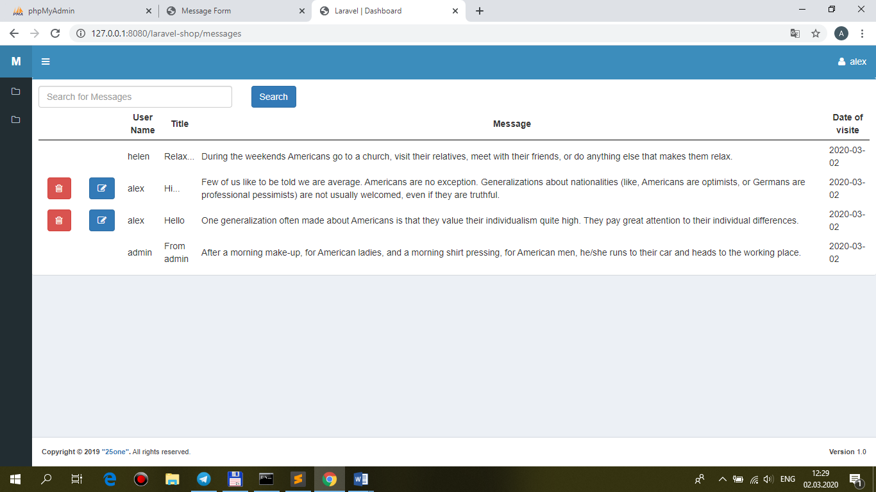

…**alex -> Title -> Hi-hi**

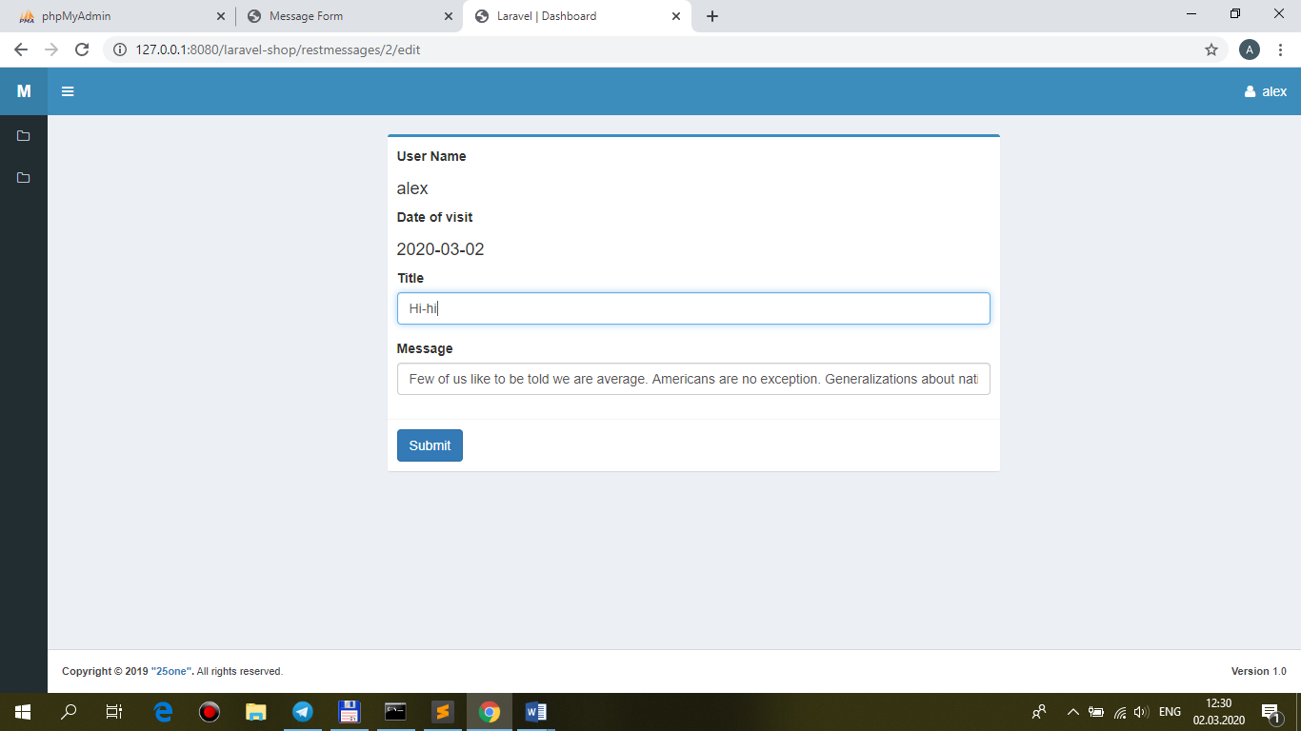

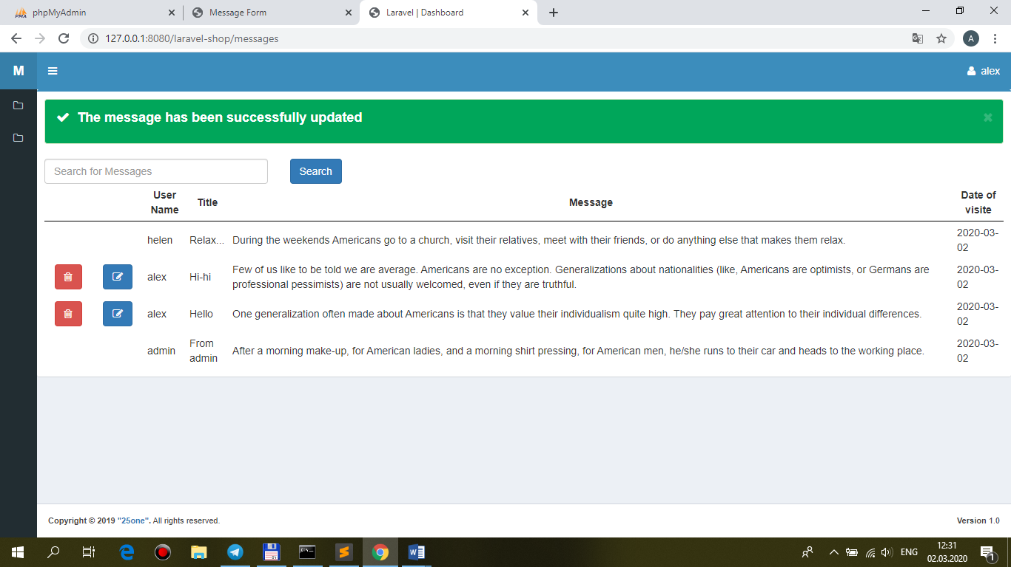

+**валидация** с использованием **MessageRequest.php**:

…**поле Title – пустое**:

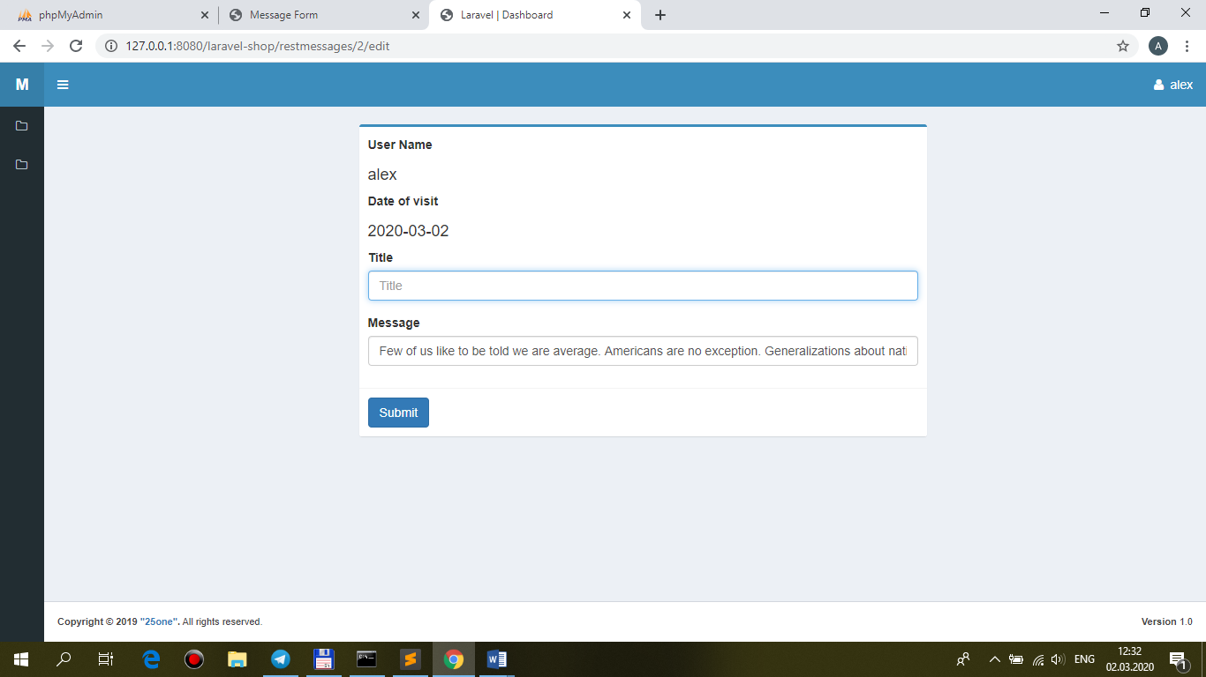

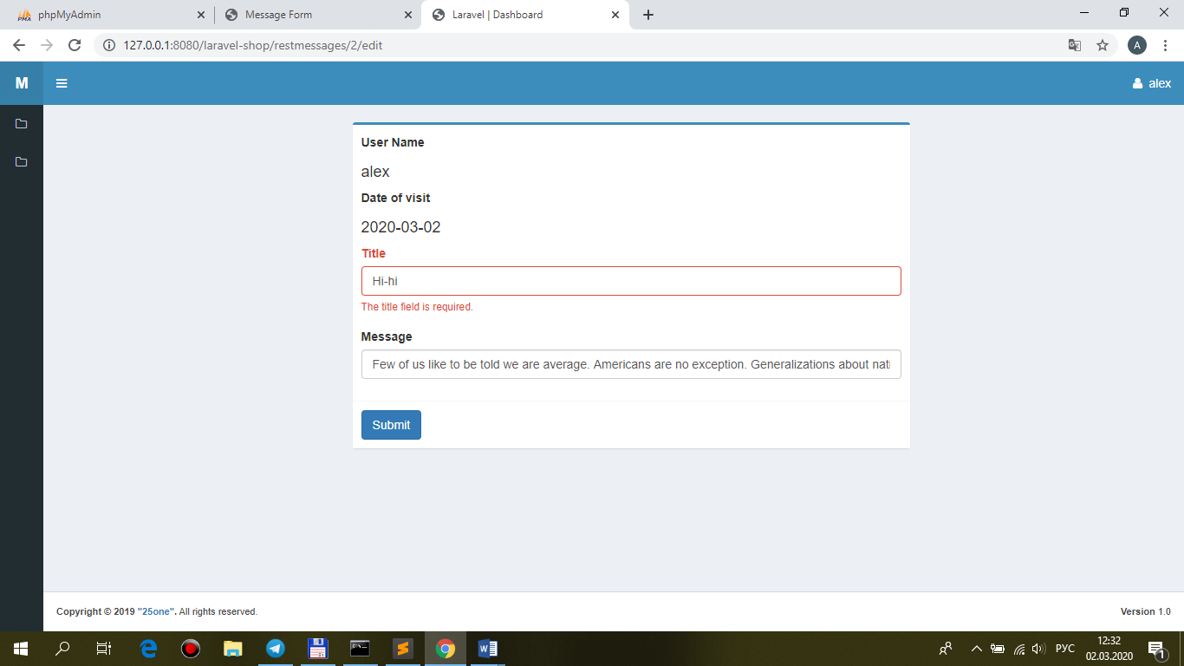

**MessageController.php**

use App\ {

Http\Controllers\Controller,

Repositories\MessageRepository,

Models\Apimessage**,**

**Http\Requests\MessageRequest**

};

…

/**

* Update the specified resource in storage.

*

* @param \App\Http\Requests\ApimessageRequest $request

* @param \App\Models\Apimessage $message

* @return \Illuminate\Http\Response

*/

public function **update(MessageRequest $request, Apimessage $restmessage)**

//public function update(Request $request, Apimessage $restmessage)

{

**$this->authorize('manage', $restmessage);**

**$this->repository->update($request, $restmessage);**

**return redirect(route('messages'))->with('message-updated',** __('The message has been successfully updated'));

}

**MessageRequest.php**

<?php

namespace App\Http\Requests;

class **Message**Request extends Request

{

/**

* Get the validation rules that apply to the request.

*

* @return array

*/

public function **rules()**

**{**

**return $rules = [**

**'title' => 'bail|required|max:255',**

**'message' => 'bail|required|max:500',**

**'datevisit' => 'bail|nullable|date|date_format:Y-m-d',**

**];**

}

}

**views\front\messages\restmessages\template.blade.php**

…

@yield('form-open')

**<input type="hidden" name="user_id" value="{{$message->user_id}}" />**

**<input type="hidden" name="datevisit" value="{{$message->datevisit}}" />**

…

**MessageRepository.php**

/**

* Update message.

*

* @param \App\Models\Apimessage $message

* @return void

*/

public **function update($request, $message)**

**{**

**$message->update($request->all());**

}